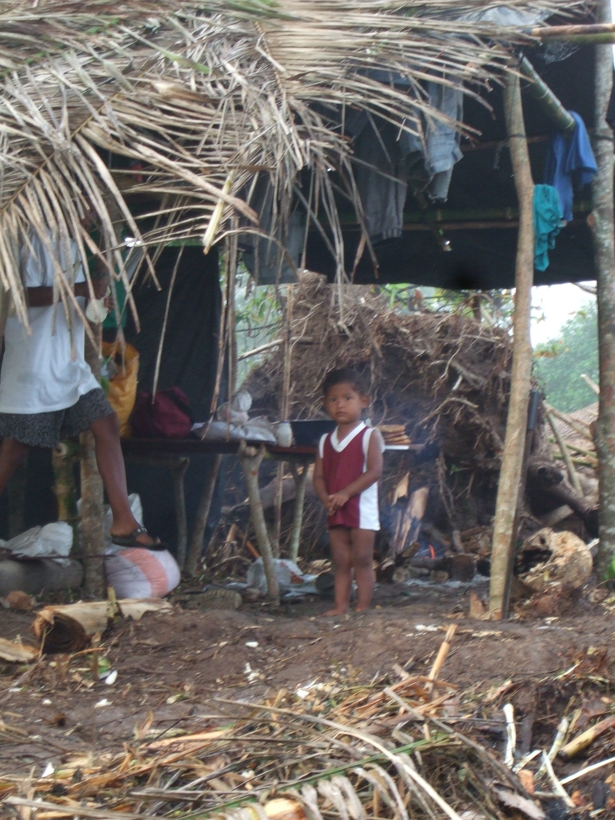

Safety Policy
&
Safety Briefing

PART 1 Safety Policy

Version 2.3 issued Dec 2016

SAFETY POLICY

CONTENTS

PART 1 Safety Policy (this volume)

- Policy and Administration | Page  2 | Introduction; Policy Statement; Safeguarding of Children and Vulnerable Adults; Responsibilities; Competencies; Meetings; Records.
- Inspections | 3
- Accident Reporting | 3
- Emergency Preparedness | 4 | Risk, Communication; Medical Assistance and Emergency Preparedness
- Safety Guidance | 4
- Hygiene and Healthcare | 4
- Personal Protection | 4

PART 2 Safety Briefing (in separate volume)

Approved by the Trustees of the Peace and Hope Trust

Chairman: Mike Gibbins

Date: Version 2.1 issued August 2014

1. Policy and Administration

Introduction:
Volunteers working in Nicaragua will be subjected to hazards with which they may not be familiar. Furthermore, volunteers from the UK travelling in Nicaragua should not presume that the indigenous people have a safety culture similar to that of the UK. These safety documents enable the Trust to demonstrate and perform a duty of care to both Volunteers and to the people of Nicaragua with regard to their health and safety.

Policy Statement:
The Trustees of the Peace & Hope Trust are committed to ensure realistic and practical health and safety environment for all volunteers and staff who travel, work and live in Nicaragua. The Trustees extend the same level of duty to the people of Nicaragua with whom they interface.

The above objective is achieved by the Trust preparing Risk Assessments and providing Trustees, volunteers and local people with the appropriate awareness, safety briefings and advice in matters of health safety and hygiene related to the Trust activities in Nicaragua.

This Policy is issued to all Trustees and Team Leaders and is available for inspection by volunteers and other interested parties and is also available on the Trust’s website.

For the purposes of this Policy, the Team Leaders are those working in Nicaragua at specific sites or on specific projects to whom the Trust has given authority to manage volunteers in the best interests of the Trust, the volunteers and the local people. Every Volunteer will be advised who their Team Leader is before travel, or upon arrival.

No volunteer or staff member will expected to undertake an activity against their wishes on the grounds of risk.

Safeguarding of Children and Vulnerable Adults:
The Trust will establish a Safeguarding Policy which will include guidelines for Volunteers to interact with children and adults in the best interests of those people.

Responsibilities:
Ultimate responsibility for the health and safety of all volunteers in Nicaragua rests with the Trustees. This is delegated to the Team Leaders during field trips to Nicaragua. However, all volunteers have a responsibility for the health and safety of themselves and others as far as they are able.

The Trust will appoint a Safety Manager for each trip with responsibility for real-time monitoring and execution of this Policy and accountable to the Team Leader.

All volunteers (or Parents, as appropriate) will submit a signed Declaration of Health before travel to Nicaragua. In certain circumstances the Trust may require a supporting health confirmation from a Doctor.

Travel: Normal commercial airline operators’ safety obligations will apply to air travel to/from and within Nicaragua and for which the Trust accepts no direct safety responsibility. The Trust and Team Leaders are responsible for motor vehicle and boat travel within Nicaragua and will seek appropriate undertakings and insurance from regular local transport providers where possible. Where this is not possible the Trust will take a view, being mindful of the Nicaraguan standard of risk, and advise volunteers accordingly.

All vehicles owned by the Trust will be subject to proper maintenance regimes by local competent mechanics. Other vehicles will be hired from local sources with good record of maintenance procedures.

From time to time the Trust will facilitate the work of independent visitors to Nicaragua who are sympathetic to the work of the Trust but are acting independently of the Trust in day-to-day activities for the people of Nicaragua. The Trust can accept no responsibility for their health and safety beyond a duty of care to provide advice.

Competencies:
The Trust will ensure that only suitably competent and (where appropriate) licensed drivers will drive motor vehicles and boats owned or hired by the trust and used in the field.

The Trust will provide appropriate guidance for the care and maintenance of the Trust’s boats. Generally, all boat trips will be commenced in the morning to allow a daylight safety margin for any unplanned event.

Team Leaders are appointed by the Trust for specific tasks/projects and will be of appropriate practical and social skills to manage volunteers and local people as necessary.

Volunteers who serve specifically in a medical capacity will hold current and valid certificates of competence or other professional licences and make arrangements for their professional indemnity insurance to be extended for the work in Nicaragua. If required to, they will declare to the Nicaraguan health authorities details of instruments and medication that they may be taking into the country.

Those who serve as assistants to the medical volunteers will have undergone suitable briefing and/or training to the satisfaction of the medical volunteers they support.

Where local staff are engaged for preparing meals they will be trained in matters of food hygiene and use of potable water, appropriate to UK volunteers.

Meetings:
Matters of safety will be discussed and safety performance reviewed as a standard agenda item at formal meetings of the Trust and minutes recorded accordingly. Changes to this Policy, the Risk Assessment and Safety Briefing will be considered annually or more often if circumstances so dictate.

In addition the Team Leaders will hold daily briefing meetings relating to daily work activity and local issues.

Records:
Records relating to Safety are held by the Trust’s secretariat.

2. Inspections & Audit

The Trust will arrange for periodic internal audit of adherence to this Safety Policy.

3. Accident Reporting

The Team Leaders will keep an Accident Book and record incidents and accidents and record the usage of the First Aid kits.

All accidents, near misses and injuries will be reported to the Team Leader as soon as possible and at the daily briefing meetings and recorded. Immediate corrective actions will be instructed and recorded as appropriate and advised to other Team Leaders.

Any breakage or failure of any safety significant equipment or fittings will also be reported as above and remedial measures put in place.

The field Safety Manager will provide the Trust with a closing report after each trip.

4. Risk Assessment & Emergency Preparedness

A safety Hazards and Risk register will be prepared by the Trust as part of the Risk Assessment Regime.

Communication:
Mobile ‘phone communication will be available for each Team Leader for communication to each other and, in emergency situations, to the UK. The Team Leaders will have readily available the phone numbers for emergency services and emergency contact numbers for volunteers.

Each sub-team will communicate with other teams each night (suggest at 7:00 p.m.) and confirm all is well.

Medical Assistance and Emergency Preparedness:
Each Team Leader will be responsible for maintaining a First Aid box for ready use in the case of injuries and for recording the use thereof. First Aid will be available ‘on site’ at project locations.

The Trust will seek to have at least one volunteer in each team trained in First Aid.

Fire detection and extinguishing and evacuation arrangements will be provided and maintained in the properties made available or rented by the Trust for occupation by Volunteers

Buoyancy Aids will be provided for boat travel.

Emergency Preparedness Plans and local safety information will be prepared and displayed where appropriate for each trip.

5. Safety Guidance

Guidance for all volunteers will be provided by the Trust. Please see Part 2 Safety Briefing

Wherever possible all new volunteers will attend a Safety and cultural briefing session before their trip. All volunteers will declare their understanding of the Safety Briefing and their willingness to comply with the same, before travel and annually. Parents of volunteers under 18 yrs will be required to declare their child’s suitability for working in Nicaragua and give their approval to their child’s involvement.

6. Hygiene and Health Care

Clear instructions on personal hygiene and health care are contained in the Safety Briefing. Instruction will also be given to all volunteers on arrival.

The Trust will arrange for a reasonably balanced menu of rice, vegetables, protein and fresh fruit daily as far as local availability allows. Potable water will be provided.

Local catering assistants will be advised as to the UK standards in hygienic food preparation and storage.

7. Personal Protection

The Trust will provide buoyancy aids for all volunteers. In some locations mosquito netting may also be required. Guidance on suitable kit, clothing, personal protective equipment and medical supplies will be provided in the Safety Briefing.

